Membership Renewal for 2017
ESP Alpha Beta Chapter is moving to an online membership renewal program for our 2017 membership year. You'll notice we have not coupled renewal with conference registration this year. We are working with National ESP to provide an online renewal process. The deadline for renewal for Georgia is January 1, 2017 BUT-you should start early if you need to submit an invoice to your county for payment. In order to renew your membership for 2017 go to https://epsilonsigmaphi.wildapricot.org/ to renew.
As a renewing member, your information
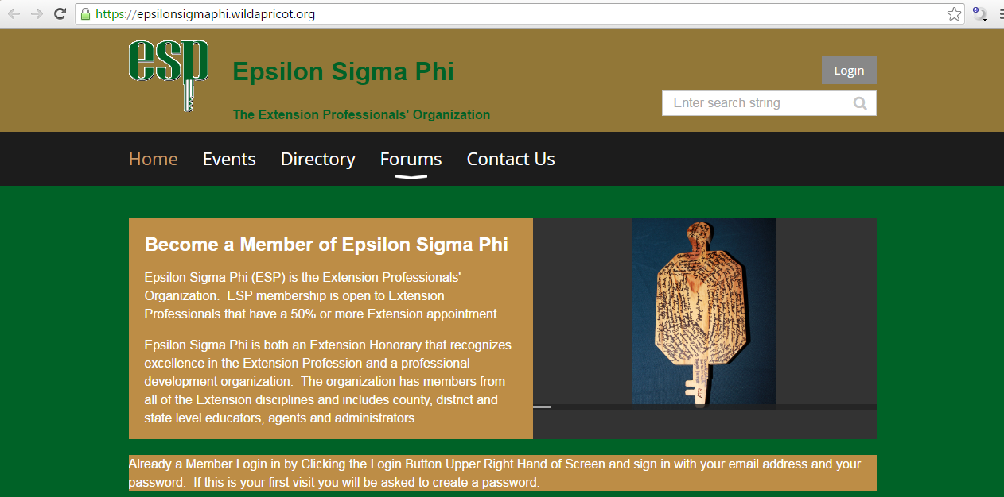
already exists in this registration system.
Choose the Login button:

On the login page, enter your email address and then choose "Forgot Password" and follow the steps to create a new password.
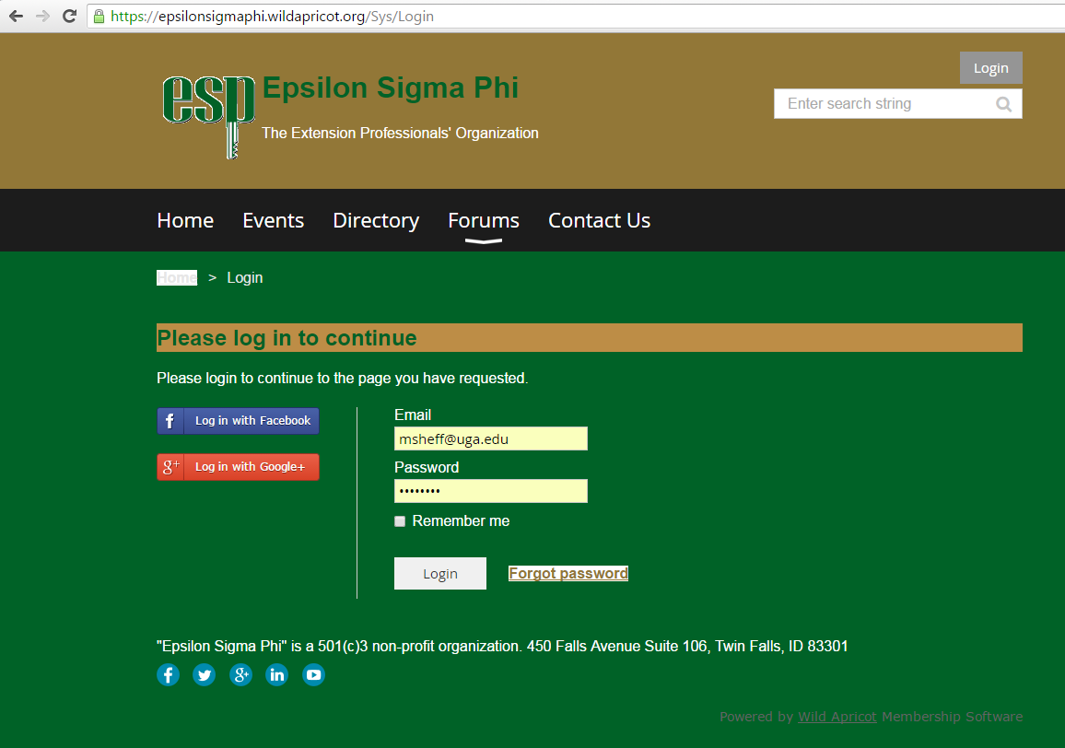

Once you arrive at your homepage, choose to "Edit Member Profile":
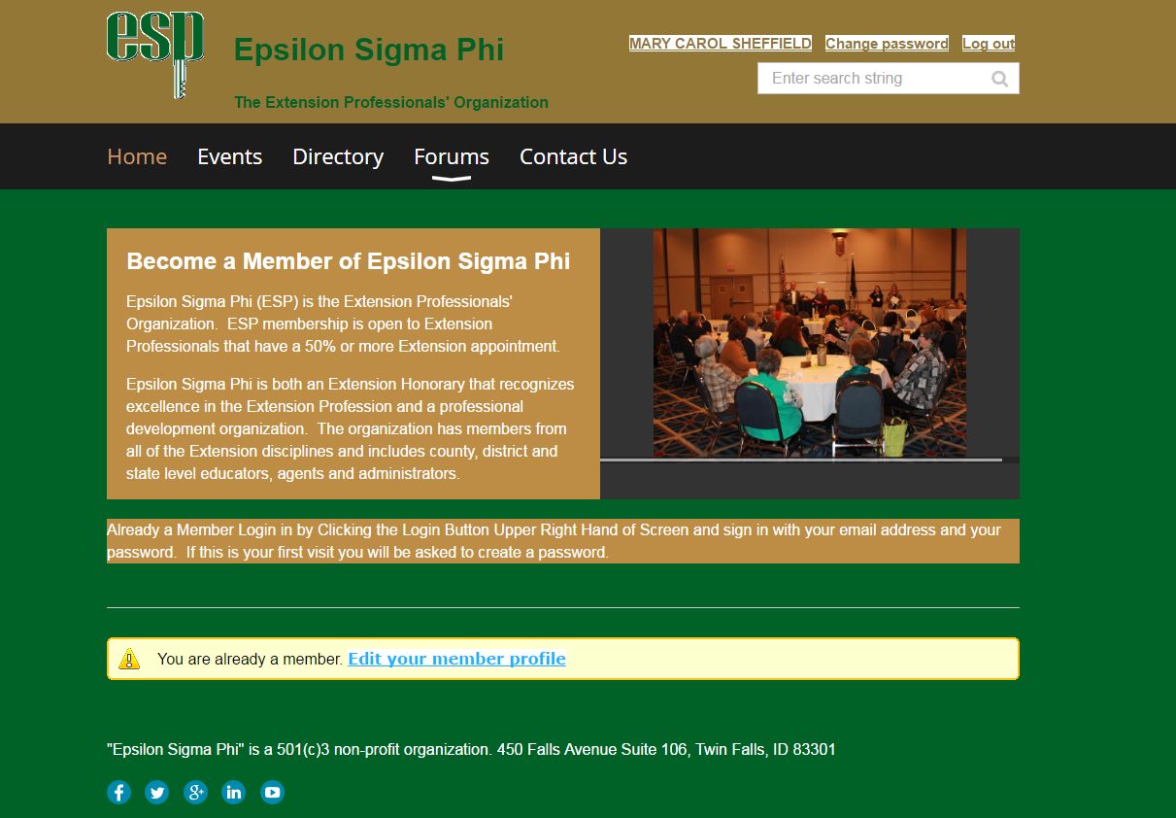
On your member profile, you will see the due date for your renewal. Choose the button on this screen to Renew

You will update your profile information and choose the Georgia-Alpha Beta Chapter. Also, choose GA under Chapter dues. Your total dues should equal $60:

At this point you will come to the payment page, where you may pay online by Credit Card, or you may print an invoice for submission to your County government, if needed.

