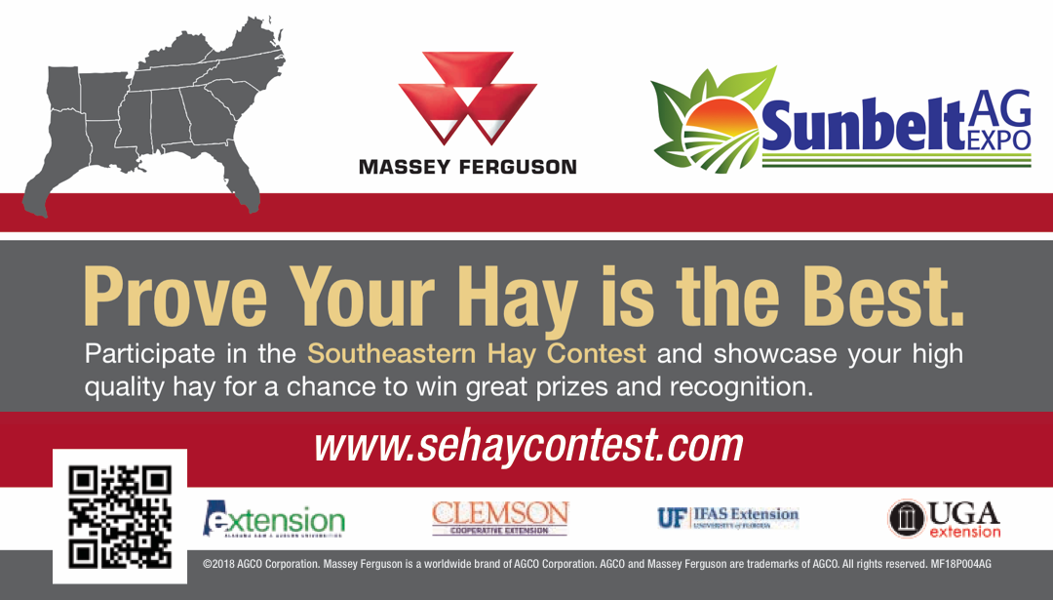
Winners will be announced on the first day of the
SUNBELT AG EXPO October 15, 2019

The 2019 Southeastern Hay Contest is presented by Massey Ferguson and is sponsored in part by:
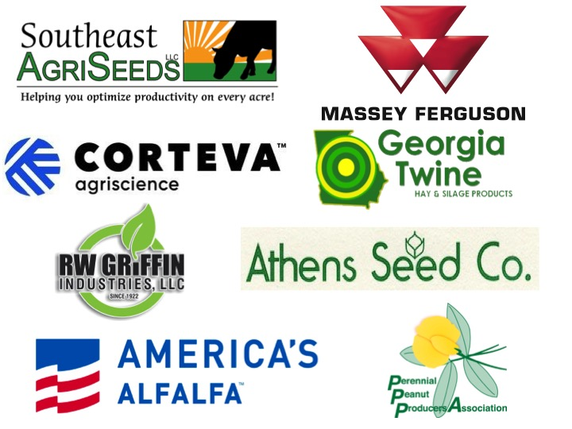

Hay/Baleage Evaluation

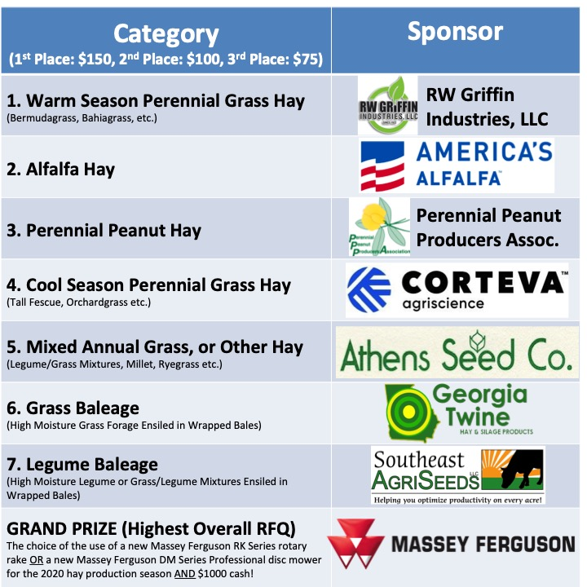
Hay and baleage samples will be evaluated in the 7 following categories:
Entries will be judged using NIR testing procedures by the University of Georgia Feed and Environmental Water (UGA-FEW) Lab. The entries will be ranked on the basis of Relative Forage Quality (RFQ), which accounts for protein, energy, and fiber digestibility. If necessary, ties in RFQ scores will be broken based on crude protein and total digestible nutrients (TDN) values.

Prizes will be awarded to the winning entries of the above seven categories of the contest as described below:
• GRAND PRIZE (Overall Highest RFQ): The choice of the use of a new Massey Ferguson RK Series rotary rake or a new Massey Ferguson DM Series Professional disc mower for the 2020 hay production season AND $1000 cash!
• 1st Prize in Each Category: $150
• 2nd Prize in Each Category: $100
• 3rd Prize in Each Category: $75

To qualify for entry to the SE Hay Contest, the producer and submitting County Extension Agent must complete the Contest Entry Form. This form, along with a $22 check ($20 for the testing fee plus $2 for Hay Contest entry fee) made payable to UGA FEW Lab, MUST BE SUBMITTED SIMULTANEOUSLY to:

Southeastern Hay Contest
Feed and Environmental Water Lab (FEW)
2300 College Station Road
Athens, Georgia 30602-4356

All Entries Must Be Received by the FEW Lab by:
5 p.m. on Thursday, September 19, 2019
Contest Rules
1. This contest is open to any hay or baleage producer from Alabama, Arkansas, Florida, Georgia, Kentucky, Louisiana, Mississippi, North Carolina, Oklahoma (east of I-35), South Carolina, Tennessee, Texas (east of I-35), or Virginia. However, entries must be submitted by the farm where the forage was grown. Because of climatic conditions that differ west of Interstate-35, all samples must originate from fields located east of I-35.
2. Hay/baleage sample, entry form, and analysis & entry fees ($22 in total) must be received by the UGA Feed and Environmental Water Laboratory by Thursday, September 19. The fee for participation in the contest includes the “F2 test: standard NIRS testing + nitrate testing” with a fee of $20 plus an entry fee of $2 per sample. The contest entry form must be submitted with the sample. If there are multiple entries, a contest entry form must be submitted with each individual sample.
3. A completed contest entry form must be submitted by an Extension Agent. This form requires the signature of your County or Regional Extension Agent. By signing the entry form, the Agent certifies that the producer has met all contest rules/requirements. Agents must assign an entry number by state and county on the entry form. This code will be used as the sample ID for analysis and for judging (ex. FL – Jackson Co-12). The Agent also must ensure that all fields on the form are filled out correctly.
4. Lab analysis samples must be taken from a single lot of hay and from a minimum of 5-10 randomly sampled square or round bales. A lot is defined as forage taken from the same farm, field, and cut under uniform conditions within a 48-hour time period. Analysis results should be available to the producer and county agent within 7-10 days after submission. For guidance on appropriate hay sampling technique, consult the National Forage Testing Association’s guide entitled: “Recommended Principles for Proper Hay Sampling.” Submit core samples for testing in a pint or quart sized zip-type bag labeled with Sample ID as described above.
5. A portion of the hay should be collected as a grab sample for display purposes when the sample is collected. Display samples should be collected in a 1 or 2-gallon zip-type bag labeled with the Sample ID as described above. No baleage display sample is required due to storage issues. Display samples may be stored in county offices until October 2019. AGENTS: be sure you keep a copy of the entry form with the display sample. Contest winners will be notified in early October and the display sample will be requested. Do not send display samples to the UGA-FEW lab or to the State Forage Extension Specialist. Contest winners who cannot provide a display sample from the lot that was entered will be disqualified.
6. Forage samples must be taken from fields with a minimum maturity or re-growth of at least 25 days to ensure fair competition. Hay from fields with less than 25 days of growth will be disqualified.
7. Forage samples for analysis and contest entry must be collected using a hay probe type recommended by the National Forage Testing Association. For more, see: http://www.foragetesting.org/index.php?page=hay_probes.
8. Forage samples with nitrate levels over 5000 parts per million (ppm) on a dry matter basis will be disqualified.
9. Dry hay samples with over 18% moisture will be disqualified. Hay that has been treated with a hay preservative will be allowed within the crop species’ appropriate dry hay category, as long as the checkbox on the contest submission form indicates the hay preservative treatment and the moisture does not exceed levels where hay preservative treatment is expected to be effective (i.e., equal to or less than 25.0% moisture). Dry hay must have been dried in the field. The hay must not have been dried in a barn (e.g., forced air, fans, etc.). Baleage samples must be between 40 and 65% moisture (35-60% DM).
10. A representative of all winning farms (farm owner, manager, family member, County Extension Agent, or designee) must be present at the award ceremony to receive the award and prize or they will be disqualified. Grand Prize winners (equipment winners) are ineligible for the overall win for the next 3 years.
11. Each farm to be recognized for a top 3 category ranking or will receive one free admission pass to the Sunbelt Ag Expo.
- Contestants who place within the top 3 RFQ scores will only be eligible for the highest placement. Contestants may not claim numerous places within a category (e.g., Farm A has the 1st place RFQ score and their scores on other entries would take 2nd and/or 3rd place, but they will only receive the 1st placement with the remaining places going down the RFQ score list).
- The SE Hay Contest form is the ONLY form that must be submitted. However, it MUST accompany the sample being entered along with a check for $22. If the form and sample do not arrive together, this sample will not qualify for entry into the contest. If the lab had previously tested forage that was not submitted officially with an SE Hay Contest form and one wishes to enter this forage in the contest, they must submit another sample to the lab accompanied by the SE Hay Contest form and the fee.

Southeastern Hay Directory (optional)

1. Participation in the 2019 Southeastern Hay Directory is an option that is exclusively available to 2019 Southeastern Hay Contest participants. The purpose is to promote the sale and purchase of high quality forage that is produced locally. The SE Hay Directory will not facilitate online purchasing, but it will help to connect buyers with sellers.

2. The SE Hay Directory can include the SE Hay Contest participants’ business name, contact information, and website. They will also have the ability to upload a small logo and a short advertisement (see the example below).

3. The SE Hay Directory is maintained on the University of Georgia Feed and Environmental Water (UGA-FEW) Lab (http://aesl.ces.uga.edu) with links provided to it from the state forage websites (e.g., www.alabamaforages.com, www.georgiaforages.com), as well as from the SE Hay Contest website (sehaycontest.wordpress.com).

4. The cost to be listed in the SE Hay Directory is $8 (in addition to $22 required for participation in the SE Hay Contest).

For Questions Concerning Show Entry or the Hay Directory Contact:
The University of Georgia’s Feed and Environmental Water (UGA-FEW) Lab at 706-542-7690 or sahau@uga.edu. For more: http://aesl.ces.uga.edu.

For General Information about the SE Hay Contest Contact:

Lisa Baxter
University of Georgia Forage Specialist
229-386-3459
baxterl@uga.edu

John Andrae Clemson University Forage Specialist
864-656-3504 jandrae@clemson.edu

Leanne Dillard Auburn University Forage Specialist
334-844-7514
dillasa@auburn.edu


Marcelo Wallau
University of Florida
Forage Specialist
352-273-2216
mwallau@ufl.edu




The Southeastern Hay Contest is open to any hay producer in the southeastern U.S. without regards to race, color, sex, age, disability or national origin.

Entry Form (use separate form for each entry)
Will Participate in: □ SE Hay Contest Entry Only ($22) □ Both SE Hay Contest & Hay Directory ($30)
State: |  | County: |  |  |  | Entry #
Category: (Check Only One □)  1) Warm Season Per Grass Hay □  2) Alfalfa Hay: □  3) Perennial Peanut Hay: □  4) Cool Season Per Grass Hay □  5) Mixed, Annual Grass, or Other Hay:  Mixed Grass, Annual Grass, or Other □  Legume+Grass Mixed: □  ________% Legume (estimated)  6) Grass Baleage □  7) Legume Baleage □  HAY PRESERVATIVE USED: □YES □NO |  | Harvest Date: (month/day/year) |  |  |  |  | Field ID
 |  | Forage Species and Variety: (i.e. Bermudagrass-Tifton 85, Bahiagrass-Argentine, Perennial Peanut-Florigraze, etc.)
 |  | Age or Maturity: (# of days from greenup or last cutting)
 |  | Comments:
Producer’s Contact Information
Farm or Ranch Name: |  |  |  | E-mail:
Address: |  |  |  |  | Phone:
City: |  |  | State: |  | ZIP:
Privacy Policy: Contact information will be used by the Contest organizers and sponsors to communicate with participants about their entry and to notify prizewinners. Contest organizers and sponsors may also contact Contest participants with special offers. Participants wishing to OPT OUT of these additional offers must initial here x______.
County Extension Office Contact Information
County Extension Agent (print)
Address:
City: |  |  | State: |  | ZIP:
Phone: | Fax: |  |  |  | Email:
I hereby certify that, to the best of my knowledge, this entry meets all the rules associated with the Southeastern Hay Contest. I also confirm that both the Southeastern Hay Contest Entry Form and a check for □ $22 (SE Hay Contest Entry Fee) or □ $30 (SE Hay Contest Entry Fee and Hay Directory Fee) are being sent simultaneously to the UGA-FEW Laboratory.
County Agent Signature

ALL FIELDS ARE REQUIRED (except the Comments field).

For 2019 Hay Directory Participants Only

A. General Information about the Business to be Included in the Hay Directory

Forage Type for Sale:
Name of the Business:
Address:
Phone:
Mobile:
E-mail:
Website:

B. Brief Advertisement about the Forage for Sale (Must Not Exceed 350 Characters Including Spaces.
/Please write legibly.)

Privacy Policy: By participating in the Hay Directory, participants agree to allow their contact information (as provided above) to be made publicly available on the Hay Directory’s website.

