Send your completed paper to Sandy Rutter at rutter@asabe.org by 12 May 2006 to be included in the meeting CD-ROM. After the meeting, papers will also be included in the
ASABE Online Technical Library.
If you can’t use this Word document and you’d like a PDF cover sheet please contact Sandy.
Please have Word’s AutoFormat features turned OFF and do not include hyperlinks. Your paper should be no longer than 12 pages. For general information on writing style, please see http://www.asabe.org/pubs/authguide.html.
This page is for online indexing purposes and should not be included in your printed version.

Author(s)
First Name | Middle Name | Surname | Role | Email
S. | Edward | Law | Yes -0004530 | edlaw@engr.uga.edu

Affiliation
Organization | Address | Country
University of Georgia, Department of Biological & Agricultural Engineering | Driftmier Engineering Center, Athens, GA 30602-4435 | USA

Author(s) – repeat Author and Affiliation boxes as needed—
First Name | Middle Name | Surname | Role | Email
Hazel | Y. | Wetzstein | No | hywetz@uga.edu

Affiliation
Organization | Address | Country
University of Georgia, Department of Horticulture | Miller Plant Sciences Bldg., Athens, GA 30602 | USA

Publication Information
Pub ID | Pub Date
064099 | 2006 ASABE Annual Meeting Paper



An ASABE Meeting Presentation
Paper Number: 064099

Ambient Ozone Concentrations Measured in Floricultural Greenhouses
S. Edward Law – Brooks Distinguished Professor
Department of Biological and Agricultural Engineering, University of Georgia, Athens, GA 30602-4435, USA, edlaw@engr.uga.edu
Hazel Y. Wetzstein – Professor

Department of Horticulture, University of Georgia, Athens, GA 30602, USA, hywetz@uga.edu

Written for presentation at the

2006 ASABE Annual International Meeting

Sponsored by ASABE

Portland Convention Center

Portland, Oregon

9 - 12 July 2006

Abstract. The US green industry has expanded remarkably over the past 10-15 years to supply the nation’s landscaping and interiorscaping markets. Greenhouse production of floricultural products, which has increased 10-fold during the past three decades, now represents a growth industry whose vitality must be ensured. Air pollution, especially the pervasive and highly oxidizing gaseous pollutant ozone (O₃) which can commonly attain ambient concentrations in the 50-150 ppb range, is widely known to detrimentally impact agronomic, horticultural, and forestry plant production. Our present work focuses upon ozone exposure for greenhouse-grown floricultural plants. Experimental measurements at 10-minute intervals throughout an August-December “ozone season” document the ambient concentrations of ozone both inside and outside commercial greenhouses and correlate these data with simultaneously measured solar irradiation and air temperature values. Season-averaged diurnal patterns show 1.76-fold increased indoor vs. outdoor O₃ concentrations during the 7-hour most active daily period of photosynthesis (0900-1600 h) when plants are highly vulnerable to ozone. We thus hypothesize that a greenhouse may act as an ozone-producing reactor exacerbating potentially injurious exposure to greenhouse plants.

Keywords. Ozone, Air pollution, Greenhouse, Floriculture, Plant injury, Solar irradiation, Photosynthesis, Ozone exposure index, Photochemical oxidant.

Introduction

Origin and Incidence
Ozone, the three-atom allotrope O₃ of oxygen, is the most important phytotoxic air pollutant in the USA and Canada and prompts increasing concern worldwide. Ground-level atmospheric ozone accumulates from: a) O₃ naturally produced by ultraviolet (λ< 242 nm) photolysis of molecular oxygen in the stratosphere which subsequently circulates downward to the troposphere via large-scale eddies in the jet stream; and b) O₃ photochemically produced in the troposphere by oxidation of gaseous hydrocarbons in the presence of nitrogen oxides NO_{x} and near-UV photons (λ < 400 nm) provided by solar irradiation. Less significant amounts are produced by electric discharges of lightning. In contrast to primary air pollutants emitted directly from man-made sources, ozone is classified as a secondary air pollutant because it is formed in the atmosphere from hydrocarbon and NO_{x} precursors which are themselves either directly contributed by anthropogenic emissions or, in the case of highly reactive hydrocarbons such as isoprene and α-pinene, by natural emissions from trees. Estimates indicate that even in urban areas, summertime emissions of biogenic hydrocarbons from trees (~30-65 kg km⁻² day⁻¹) may exceed anthropogenic emissions of ~30 kg km⁻² day⁻¹ (Westberg and Lamb, 1985; Ga. EPD/SIP, 2001). In comparison, the source of the nitrogen oxide precursor necessary for O₃ formation is mainly high-temperature combustion processes, with biogenic emissions nil (Logan, 1983).
Ozone’s impacts are regional and extend downwind hundreds of miles from sites of precursor emissions. Not surprisingly for example, Georgia O₃ values monitored in the smaller cities of Athens and Conyers often exceed those in metropolitan Atlanta (www.air.dnr.state.ga.us). While highly site specific, atmospheric ozone concentrations also vary seasonally and diurnally, exhibiting maximum values following periods of intense solar irradiation. Ambient O₃ concentrations are accentuated during the hot, stagnant-weather conditions of the June-September “ozone season”. During this period human populations in non-attainment areas may be exposed to high ozone levels as gauged by the 120 ppb (volume basis) 1-hour averaged concentration promulgated over past decades as the National Ambient Air Quality Standard. The U.S. Environmental Protection Agency currently specifies an 85 ppb 8-hour-averaged standard to protect public health with an extra margin of safety and above which the air is considered unhealthy to breath (Lefohn, 1997).

Previous Studies of Crop Exposure
Beyond concerns for human health, numerous studies over the past five decades have documented the adverse effects of tropospheric ozone on agricultural crop growth and productivity (Lofohn, 1992). The scale of these studies has spanned over the cell, organ, whole plant, and population levels. Ozone concentrations imposed have included both acute exposures (i.e., relatively high concentration episodes over several hours) producing visible injury symptoms, and chronic exposures (i.e., relatively long, low-level O₃ concentrations) resulting in reductions of plant growth, productivity, and quality. As summarized from dose-response studies by many investigators, maximum acceptable ozone concentrations have been proposed for the protection of vegetation from injury and damage (Guderian et al., 1985). While sensitivity depends upon various biological and environmental factors and stresses which determine uptake of ozone by vegetation, generally for ozone-sensitive species 4-hour exposures at 50 ppb should not be exceeded; correspondingly, 100 ppb is proposed for species of intermediate sensitivity. Unfortunately, many agricultural regions in the USA and Europe routinely experience O₃ averages exceeding this lower figure and peak values at times exceeding ~150 ppb on an hourly basis; appreciable economic losses result (Heck, 1989; WHO, 1987).
Thus, much is known regarding the occurrence and crop-level exposures of atmospheric ozone (Manning and Krupa, 1992), its uptake by vegetation (Runeckles, 1992), and various crop responses to uptaken ozone from biochemical and physiological perspectives (Runeckles and Chevone, 1992). The dominant route of entry of ozone into plants is gaseous diffusion through open stomata of foliage with much lower uptake via sorption and transfer through cuticular and epidermal layers. Once inside the leaf, the relatively high gas permeability of the spongy mesophyll facilitates transfer of O₃ to its sites of attack. Ozone is a highly reactive oxidant known to directly react with various biological systems irreparably altering cellular membranes, etc. (Law and Diaz, 2001). Within plant cells it acts upon various metabolites (Heath, 1984) and its toxicity may be attributable to lipid peroxidation and ozonolysis of the plasma membranes negating selective permeability. Additionally, once ozone becomes dissolved in water within the leaf, its decomposition products include the extremely reactive hydroxyl free radical. Free radicals form the basis for advanced oxidation processes shown to have synergistically adverse effects at the cellular level (Diaz and Law, 2001). Thus, hydroxyl and other free radical species associated with water-dissolved ozone likely exacerbate the adverse effects of ozone exposure both within the moist leaf and upon wet stigmas and other flower components. Solar UV directly irradiating water films on exposed stigmatic surfaces possibly photolytically drives dissolved ozone’s decomposition to exacerbate detrimental free-radical effects upon reproductive processes.

Greenhouse Floricultural Crops
In contrast to numerous published articles as summarized above investigating the incidence and effects of atmospheric O₃ upon outdoor agronomic, horticultural and forestry crops, few have focused upon commercial floricultural crop production within the confines of greenhouses. Likewise, most have investigated uptake of O₃ by foliar surfaces, its subsequent physiological and biochemical effects, and resulting reductions of vegetative growth, biomass yield and quality. Information is limited regarding the effects of O₃ upon flowering and reproductive processes. Detrimental ozone effects have been shown in the few reproductive studies done: tobacco (Feder, 1968); petunia (Feder and Sullivan, 1969); tomato (Feder et al., 1982); oilseed rape and wheat (Black et al., 2000); blackberry (Chappelka, 2002); potato (Donnelly et al., 2001); and Brassica species (Stewart et al., 1996). Exposures to 50-100 ppb O₃ over 1-3 month periods both delayed and reduced floral yield of carnation and geranium as well as diminished top growth, side branching and leaf size (Feder, 1970).
In summary, cellular-level effects of ozone exposure upon various biological processes (e.g., photosynthesis, translocation, biosynthesis, pollination, fertilization, etc.) ultimately impact both plant vegetative growth and reproduction (Reinert et al., 1997; Black et al., 2000). Commercial floriculture has a vested interest in ensuring healthy floral initiation and development, as well as vegetative growth, for ornamental bedding and floral plant production which is primarily greenhouse-grown. Unfortunately, a number of commercially important greenhouse plants (e.g., petunia and begonia) are ozone-sensitive species (Adedipe et al., 1972). As an example of its economic importance, for the state of Georgia alone, greenhouse production of floricultural products is valued at approximately $246 million per year – a growth sector which has expanded 12-fold over the past three decades (Boatright and McKissick, 2006). Ensuring the vitality of this sector of the green industry is economically essential at both the state and national levels. Thus, due to its strong propensity for injury to living plants, characterization of actual ozone exposure within commercial floricultural greenhouses is required.

Objective

In the absence of publications reporting ambient concentrations of ozone within commercial greenhouses, the objective of this present work was to record these data inside and outside both glass-glazed and plastic-covered greenhouses during the 2002 and 2003 ozone seasons and to summarize hourly averages of these diurnal patterns on a daily, weekly, monthly and season-long basis as well as condensing the results into ozone exposure-index values pertinent to living plants. Concomitantly, solar irradiation and outdoor dry-bulb temperature patterns also were obtained as associated environmental driving factors for ozone formation.

Experimental Analysis

General Approach
Preliminary measurements were taken in a glass-glazed research greenhouse (Athens, GA) during August 2002 where outdoor and indoor ozone concentrations were monitored and manually recorded throughout several days. More comprehensive measurements were taken throughout August-December 2003 at two plastic-covered commercial greenhouses located in Oglethorpe County and Morgan County, GA. There the four experimental variables recorded at 10-minute intervals were: a) solar irradiation (W m⁻²); b) outdoor dry-bulb air temperature (ºC); c) outdoor ozone concentration (ppb); and d) indoor ozone concentration (ppb). The first three variables were sampled atop a 6.1 m (20 ft) mast erected adjacent to the greenhouse and the final one sampled 0.5 m above crop level. Polyethylene film (Klerks K-50 clear) covered the evaporatively-cooled commercial houses.

Instrumentation
Solar irradiation was sensed using a thermoelectric global pyranometer (model 8-48, Eppley Labs, Newport, RI) and temperature by a thermister probe (model TMC50-HA, Onset Computer Corp., Bourne, MA) sheltered within a ventilated sun screen. Atmospheric ozone was sensed by the Beer’s law ultraviolet-absorption method using a flow-through (1 L min⁻¹) ozone monitor (model LC-400, PCI Ozone & Control Systems, Inc., Charlotte, NC) having a 1 ppb detection sensitivity. The monitor’s output was calibrated such that its 4-20 mA output corresponded to a measuring range of 0-120 ppb ozone concentration. All sampling tubes and other ozone-contacted surfaces were Teflon or stainless steel. A time-switched gas solenoid valve alternately directed either the outdoor or the indoor sampled air to the monitor to equally share each 10-minute measurement interval.
After appropriate voltage or current conversions and averaging, all sensor outputs were fed every 10-minute increment to a 4-channel data acquisition system (model HO8-008-004, Onset Computer Corp., Bourne, MA) having a storage capacity of 32,520 data points which was downloaded at approximately 2-week intervals using that company’s laptop computer software (BoxCar 3.7 for Windows). Subsequent data reduction was via Microsoft Excel software. Time resolution for synchronizing the overall instrumentation system was +10 s day ⁻¹. It was supplied by a constant-voltage transformer (model MCR 150, Sola Corp., Rosemont, IL), all installed in a portable water-tight cabinet.

Results and Discussion
Figure 1 plots half-hour averages for the diurnal pattern for ozone concentrations measured outdoor and indoor of the glass-glazed research greenhouse on a typical day during August 2002. Indoor values remained under 40 ppm; however, throughout the day they exceeded those measured outdoor typically be a factor of approximately 1.7-fold. The plant species, density and cultural practices in a research greenhouse may differ significantly from those of commercial production. Thus additional monitoring studies were conducted in commercial settings to ascertain if elevated indoor ozone concentrations likewise recurred.
For a commercial plastic-covered greenhouse (Oglethorpe County), Fig. 2 shows hourly-averaged diurnal ozone concentrations as averaged across the month of August 2003. Figures 3 and 4 plot corresponding hourly-averaged values showing diurnal patterns for solar irradiation and for outdoor air temperature as averaged across that month. A typical day was characterized by 24.6ºC temperature and 18.95 MJ m⁻² day⁻¹ solar energy received. Ozone concentration peaked slightly above 40 ppb and again indoor values exceeded outdoor, this time typically by ~1.3-fold during the time of most intense solar irradiation and temperature ca. 1400-1500 h.
For the other commercial plastic-covered greenhouse (Morgan County), Figs. 5-7 present experimental results for the month of September 2003. Noticeably, both ozone concentrations peaked near 46 ppb at 1800 h, several hours following maximum irradiation and temperature. Indoor ozone this month attained only ~1.1-fold excessive value over outdoor, again coincident with the time of peak irradiation. A typical day was characterized by 21.5 ºC outdoor air temperature and 18.87 MJ m⁻² day⁻¹ solar energy received. This latter value agrees well with that of 16.74 MJ m⁻² day⁻¹ (400 langleys/day) expected at mid-September as published for Athens, GA (Baldwin, 1973).
October 2003 results (Fig. 8) show peak outdoor O₃ ca. 1700 h falling below the 40 ppb level yet still exhibit an excess indoor vs. outdoor concentration of ~1.1- to 2.7-fold across a typical day. Figure 9 for December 2003 documents the expected seasonal decline in outdoor atmospheric ozone with values barely exceeding 10 ppb during the 1500-1800 h peak interval. In contrast, the indoor concentration remained much greater having a 2.6-fold excessive level during this peak interval.
The diurnal pattern for ozone concentration measurements, pooled season-long for 2003 combining both commercial greenhouses, is shown in Fig. 10. These results indicate that indoor ozone levels consistently surpassed those outdoor at all times of the 24-h day. The season-long degree of exacerbation was 1.24-fold as averaged across a day. More remarkably, the season-long 7-hour-averaged ratio across the most active period of photosynthesis (0900-1600 h) during which plants are highly subject to ozone injury was ~1.76-fold.
Indoor ozone concentrations which exceeded 0.060 ppm (i.e., 60 ppb) for 1-h exposures were summed over 3-month rolling periods to provide the SUM06 exposure-index values which have been found to generally correlate with injury to living plants (Musselman et al., 1994). This index for the August-October 2003 period, for example, was 2.043 ppm-h with 46 of the individual hour-averaged concentrations > 60 ppm and six of them > 70 ppm. That season’s maximum hour-averaged value was 88 ppb O₃ inside the Morgan County commercial greenhouse.

Conclusion
Outdoor ozone concentrations are affected by a number of factors including the incidence of precursor air pollutants, temperature, solar irradiation and prevailing weather conditions. Changes in these may explain some of the month-to-month and location variations observed in our atmospheric ozone measurements. Nonetheless, elevated indoor ozone concentrations were consistently observed compared to outdoor ambient values in spite of the fact that all three of the greenhouses monitored were well-ventilated houses. This suggests that greenhouses may somehow act as ozone-producing reactors. Hour-averaged indoor ozone concentrations recorded during 2003 summer months reached over 40 ppb as averaged on a monthly basis, and SUM06 exposure-index values indicate that growth and development of sensitive plants may be compromised under commercial greenhouse conditions. It was anticipated that the most severely injurious conditions would occur primarily during the summer “ozone season” and be related to the higher ambient outdoor conditions observed during that time. It was intriguing, however, to find that elevated indoor ozone concentrations continued in the colder months (e.g., December) at levels commensurate to that observed during the summer even though outdoor ozone concentrations were low. This implies that any physiological or growth inhibitory effects of elevated ozone within greenhouse structures may be a year-round rather than just a seasonal concern. Areas for our further study include an identification of factors causing elevated indoor ozone concentrations within greenhouse structures, and a determination if and to what extent the ambient indoor ozone concentrations observed compromise crop production of specific commercial greenhouse crops. If warranted, engineering development of ozone-abatement strategies would follow.

Acknowledgements
Appreciation is expressed to Steve McDonald for electronics design and fabrication and to Jason Governo for data analysis. The collaboration of Ken and Lea James of James Greenhouses (Oglethorpe County) and Chuck and Chris Stewart of Tapestry Greenhouses (Morgan County) in facilitating on-site measurements is gratefully acknowledged. This work was supported in part by the Georgia Agricultural Experiment Stations and the College of Agricultural and Environmental Sciences of the University of Georgia.

References
Adedipe, N.O., R.E. Barrett and D.P. Ormrod. 1972. Phytotoxicity and growth responses of ornamental bedding plants to ozone and sulfur dioxide. J. Amer. Soc. Hort. Sci. 97(3):341-345.
Baldwin, J.L. 1973. Climates of the United States. U.S. Govt. Print. Off., Washington, DC. 113 p.
Black, V.J., C.R. Black, J.A. Roberts and C.A. Stewart. 2000. Impact of ozone on the reproductive development of plants. New Phytologist 147(3):421-447.
Boatright, S.R. and J.C. McKissick. 2006. The 2005 Georgia Farm Gate Value Report. University of Georgia, CAED publication AR-06-01, Athens, GA.
Chappelka, A.H. 2002. Reproductive development of blackberry (Rubus cuneifolius), as influenced by ozone. New Phytologist 155:249-255.
Diaz, M.E. and S.E. Law. 2001. Control of pathogenic microorganisms and turbidity in poultry-processing chiller water using UV-enhanced ozonation. Ozone Sci. and Engr. 23(1):53-64.
Donnelly, A., T. Lawson, J. Craigon, C.R. Black, J.J. Colls and G. Landon. 2001. Effects of elevated CO₂ and O₃ on tuber quality in potato (Solanum tuberosum L.) . Agriculture Ecosystems and Environment 87:273-285.
Feder, W.A. 1968. Science 160:1122.
Feder, W.A. 1970. Environ. Pollution 1:73-79.
Feder, W.A., G.H.M. Krause, B.H. Harrison and W.D. Riley. 1982. Ozone effects on pollen-tube growth in vivo and in vitro. In M.H. Unsworth and D.T. Ormrod, eds. Effects of Gaseous Air Pollutants in Agriculture and Horticulture. Butterworth Scientific Publishers, London. 482.
Feder, W.A. and F. Sullivan. 1969. Phytopathology 59:399.
Ga. EPD/SIP. 2001. Georgia’s State Implementation Plan for the Atlanta Ozone Non-Attainment Area [as revised]. Ga. Dept. of Natural Resources, Environ. Protection Div., Air Protection Branch, Atlanta, GA. www.ganet.org/dnr/environ/plans_files/plans/airsipnar.pdf.
Guderian, R., D.T. Tingey and R. Rabe. 1985. Effects of photochemical oxidants on plants. In R. Guderian, ed. Air Pollution by Photochemical Oxidants. Springer-Verlag, Berlin. 129-133.
Heath, R.L. 1984. Air pollutant effects on biochemicals derived from metabolism: organic, fatty and amino acids. In M.J. Koziol and F.R. Whatley, eds. Gaseous Air Pollutants and Plant Metabolism. Butterworth, London. 275-290.
Heck, W.W. 1989. Assessment of crop losses from air pollutants in the United States. In J.J. MacKenzie and M.T. El-Ashry, eds. Air Pollution’s Toll on Forests and Crops. Yale University Press, New Haven, CT.
Law, S.E. and M.E. Diaz. 2001. Implementation of UV-enhanced ozonation for recycling food-processing wastewaters: mobile prototype case study. Proc. 15th World Cong. Internat. Ozone Assoc. 2:306-312. London.
Lefohn, A.S. 1992. Surface-Level Ozone Exposures and their Effects on Vegetation. Lewis Publishers, Inc., Chelsea, MI. 366 pp.
Leforn, A.S. 1997. New directions: a new ozone standard in the United States. Atmospheric Environment 31(22):3851-3852.
Logan, J.A. 1983. Nitrogen oxides in the troposphere: global and regional budgets. J. Geophys. Res. 88:10785.
Manning, W.J. and S.V. Krupa. 1992. Experimental methodology for studying the effects of ozone on crops and trees. In A.S. Lefohn, ed. Surface-Level Ozone Exposures and their Effects on Vegetation. Lewis Publishers, Inc., Chelsea, MI. 93-156.
Musselman, R.C., P.M. McCool and A.S. Lefohn. 1994. Ozone descriptors for an air quality standard to protect vegetation. J. Air and Waste Manage. Assoc. 44:1383-1390.
Reinert, R.A., G. Eason and J. Barton. 1997. Growth and fruiting of tomato as influenced by elevated carbon dioxide and ozone. New Phytologist 137:411-420.
Runeckles, V.C. 1992. Uptake of ozone by vegetation. In A.S. Lofohn, ed. Surface-Level Ozone Exposures and their Effects on Vegetation. Lewis Publishers, Inc., Chelsea, MI. 157-188.
Runeckles, V.C. and B.I. Chevone. 1992. Crop responses to ozone. In A.S. Lofohn, ed. Surface-Level Ozone Exposures and their Effects on Vegetation. Lewis Publishers, Inc., Chelsea, MI. 189-270.
Stewart, C.A., V.J. Black, C.R. Black and J.A. Roberts. 1996. Direct effects of ozone on reproductive development of Brassica species. J. Plant Physiol. 148:172-178.
Unsworth, M.H. and D.P. Ormrod. 1982. Effects of Gaseous Air Pollution in Agriculture and Horticulture. Butterworth Scientific Publishers, London.
Westberg, H. and B. Lamb. 1985. Ozone production and transport in the Atlanta, GA region. EPA/600/S3-85/013, U.S. Environ. Protection Agency, Research Triangle Park, NC.
WHO. 1987. Air quality guidelines for Europe. WHO Regional Publications, European Series No. 23, WHO, Copenhagen.
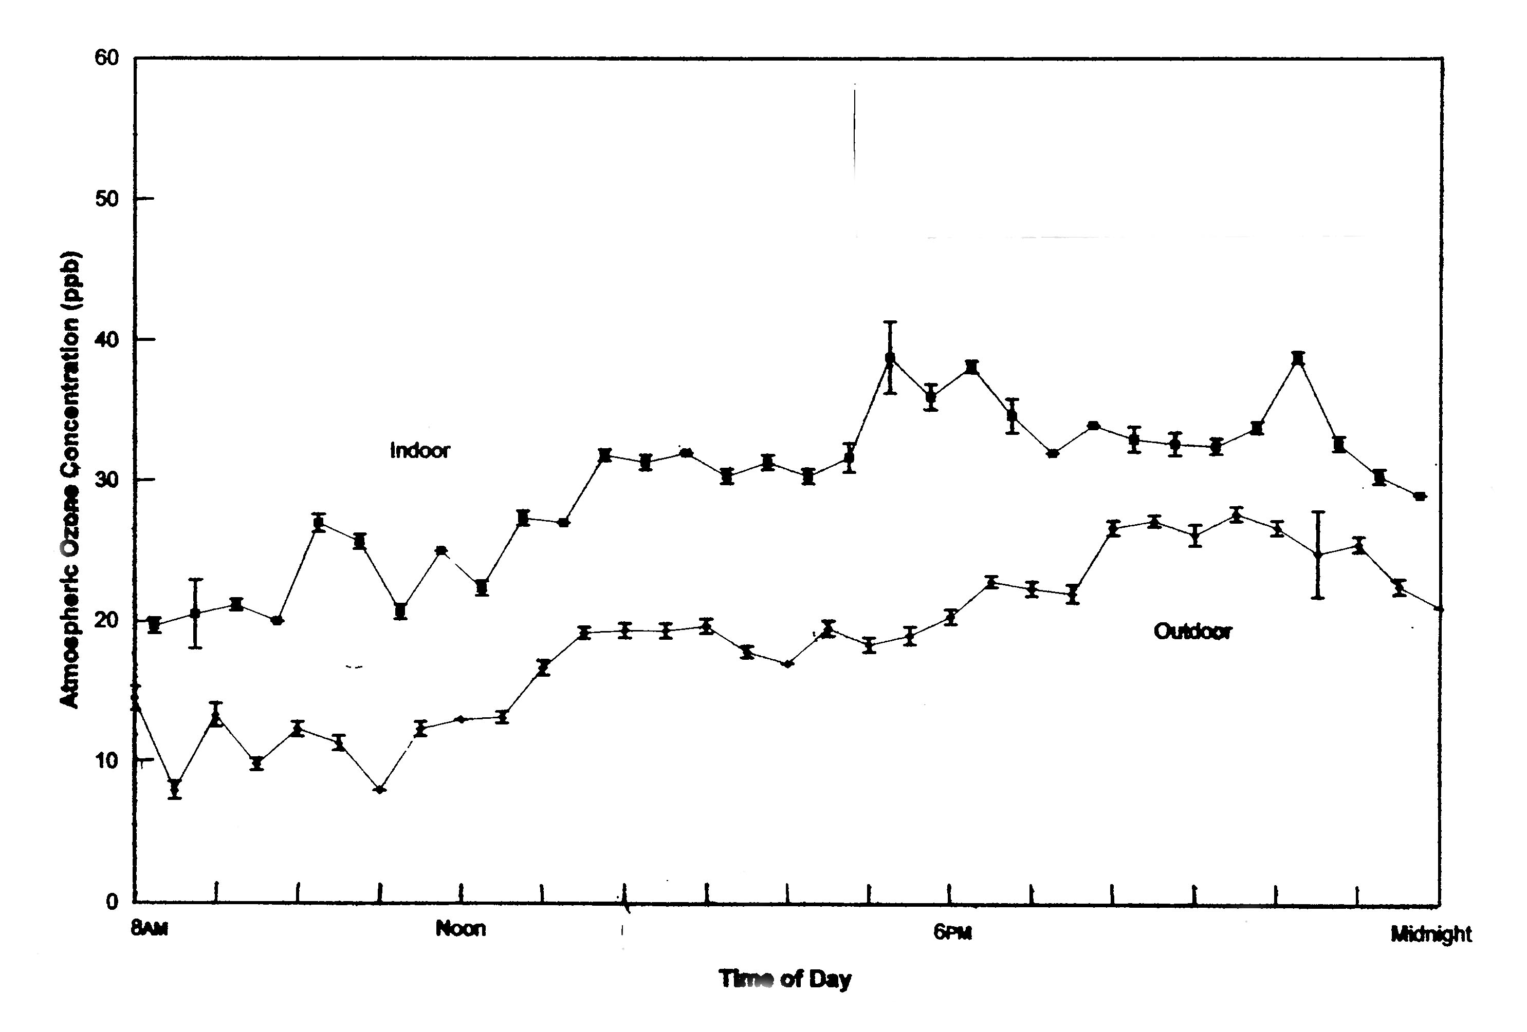
Figure 1. Ozone concentrations outdoor and indoor of glass-glazed research greenhouse, 28 August 2002, Athens, GA. (Standard error bars shown for n = 6 replications.)

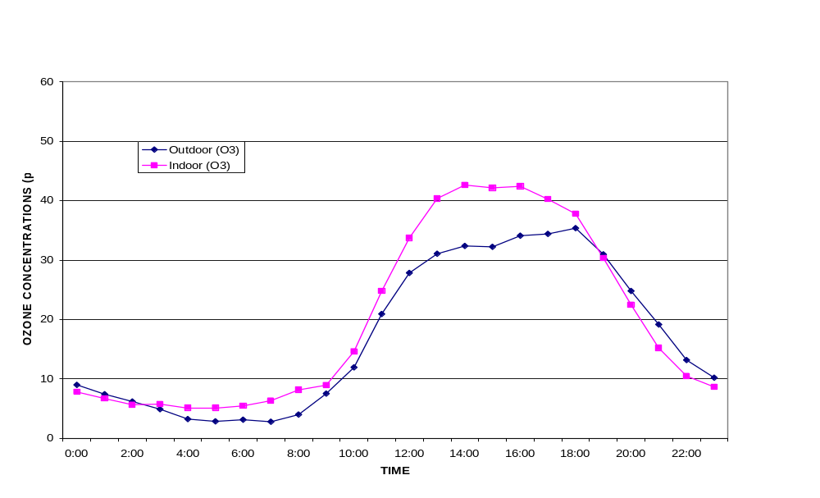
Figure 2. Diurnal ozone concentrations outdoor and indoor of plastic-covered commercial greenhouse as averaged over the month of August 2003, Oglethorpe County, GA.

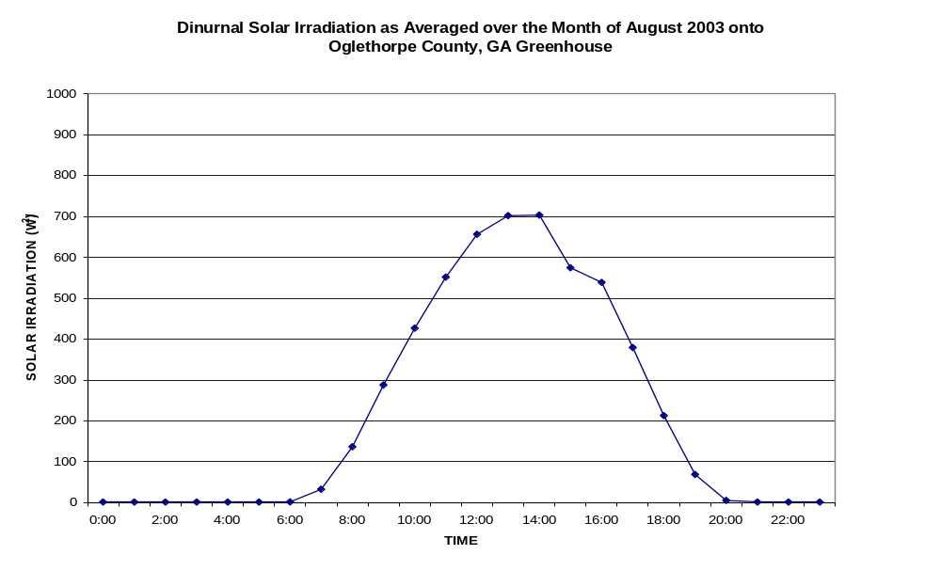
Figure 3. Diurnal solar irradiation onto plastic-covered commercial greenhouse as averaged over the month of August 2003, Oglethorpe County, GA.
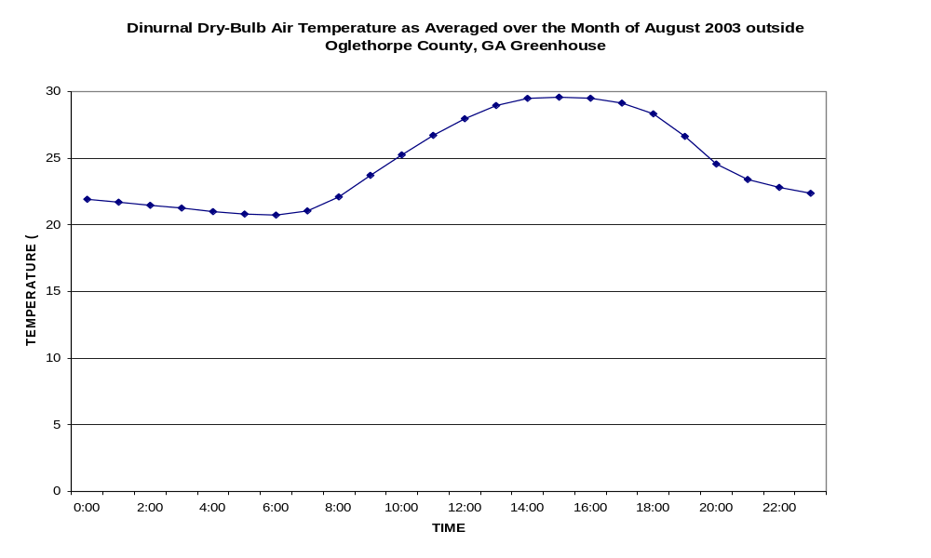
Figure 4. Diurnal dry-bulb air temperature outdoor of plastic-covered commercial greenhouse as averaged over the month of August 2003, Oglethorpe County, GA.

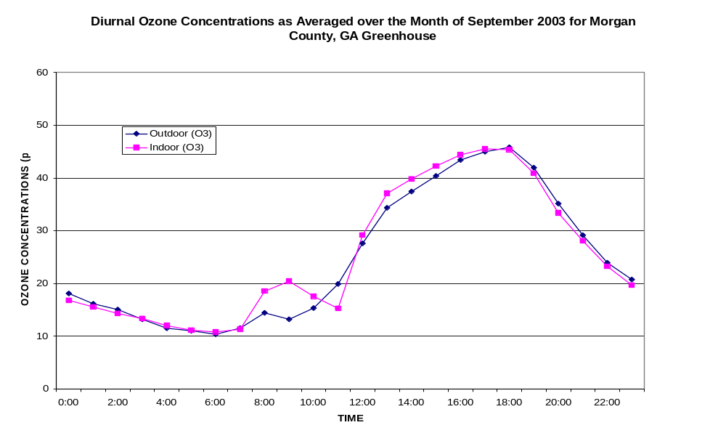
Figure 5. Diurnal ozone concentrations outdoor and indoor of plastic-covered commercial greenhouse as averaged over the month of September 2003, Morgan County, GA.
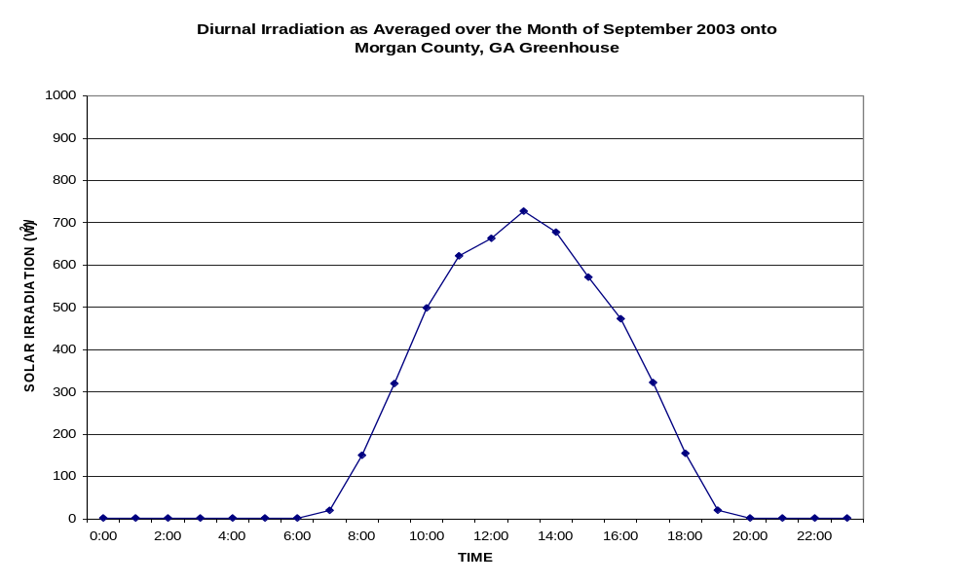
Figure 6. Diurnal solar irradiation onto plastic-covered commercial greenhouse as averaged over the month of September 2003, Morgan County, GA.
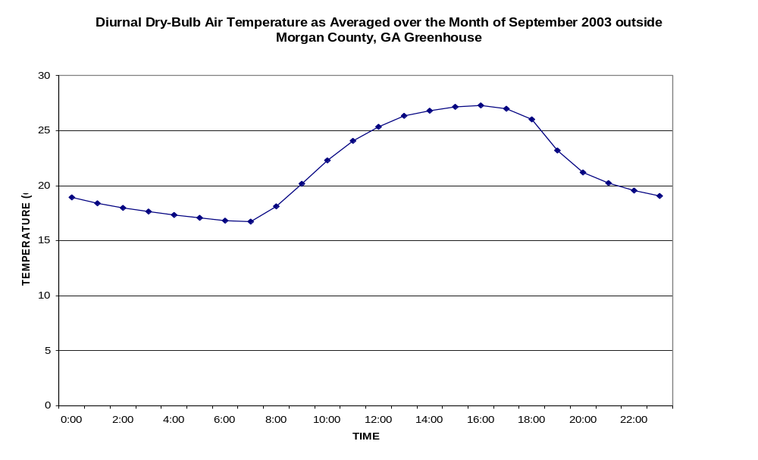
Figure 7. Diurnal dry-bulb air temperature outdoor of plastic-covered commercial greenhouse as averaged over the month of September 2003, Morgan County, GA.
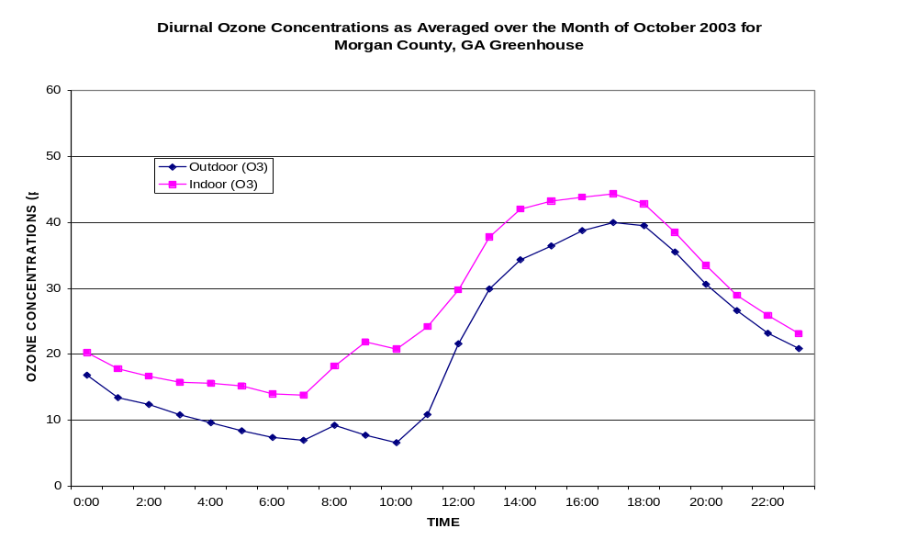
Figure 8. Diurnal ozone concentrations outdoor and indoor of plastic-covered commercial greenhouse as averaged over the month of October 2003, Morgan County, GA.

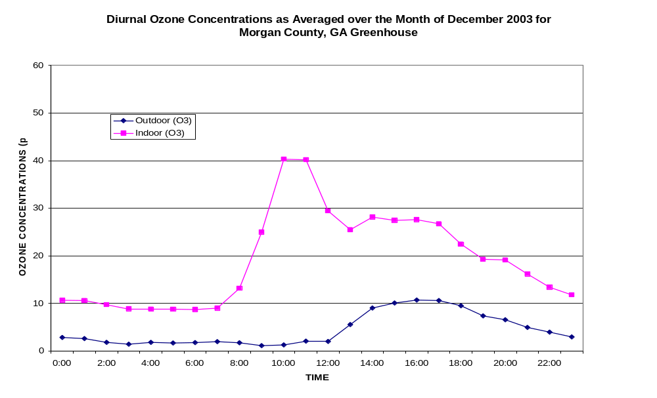
Figure 9. Diurnal ozone concentrations outdoor and indoor of plastic-covered commercial greenhouse as averaged over month of December 2003, Morgan County, GA.

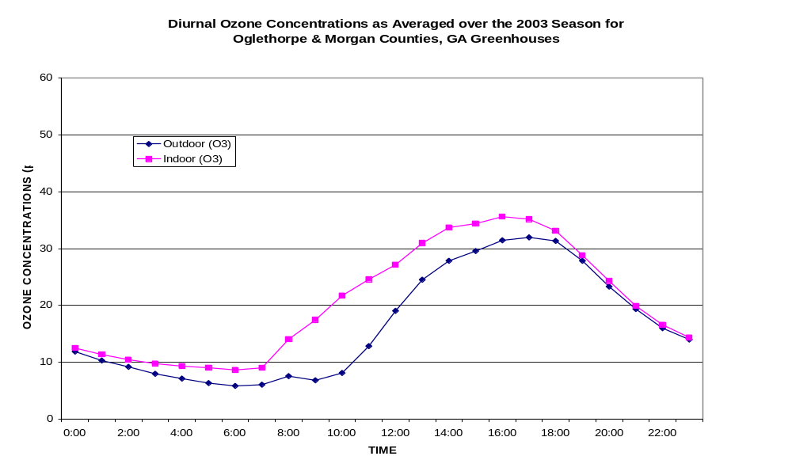
Figure 10. Diurnal ozone concentrations outdoor and indoor of plastic-covered commercial greenhouses as averaged over the 2003 season, Oglethorpe and Morgan Counties, GA.

